**Lab 3 Report**

Student number: 12161762

Name: LEE YEONG JUN

<Code>

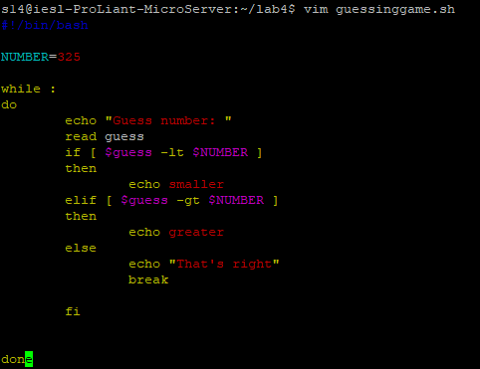

<Result>

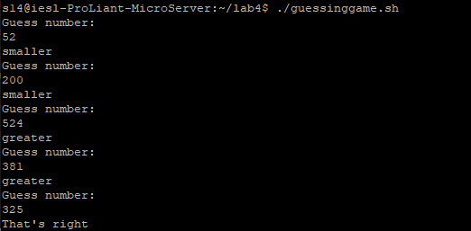

The number 325 is assigned to the variable NUMBER. And the number to be guessed is inputted by the user as ‘guess’. ‘while:’ is used to repeat infinitely until the number is matched, and when the number is matched, the sentence ‘That’s right’ is printed and the loop ends.

If [ $guess -lt $NUMBER ] → guess < NUMBER.

elif [ $guess -gt $NUMBER ] → guess > NUMBER.

else → It means the case that guess and NUMBER are the same.